Name: Thamburaj
Roll No: 240701559
AIM:
The aim is to design input forms that validate data, such as email and phone number, and display error messages using HTML/CSS and JavaScript with Validator.js
PROCEDURE:
Step 1:
Setting Up the HTML Form Start by creating an HTML form with input fields for the email and phone number.
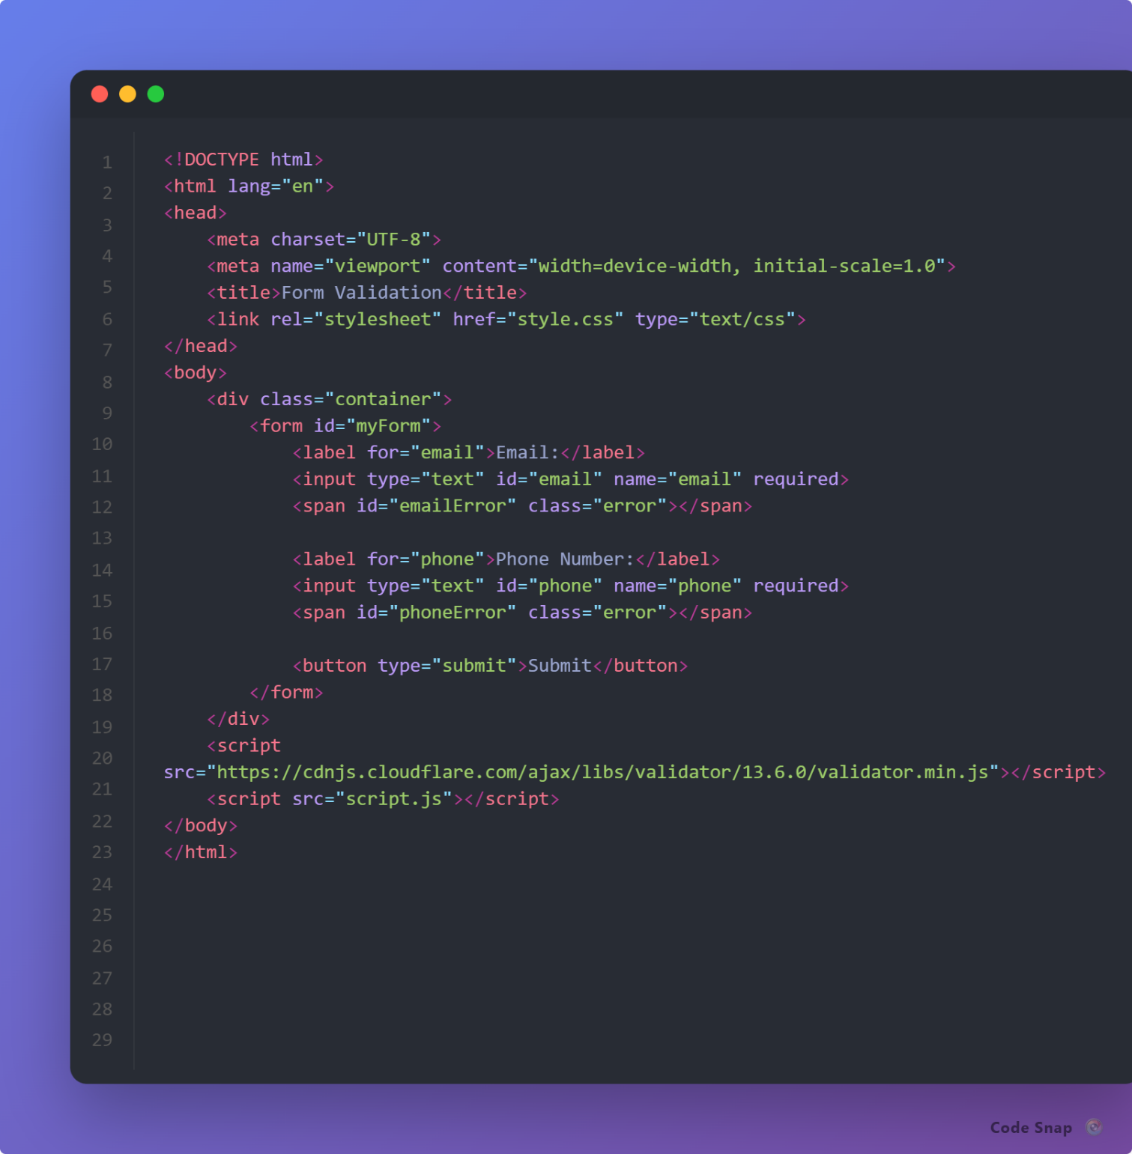

Step 2:
Styling the Form with CSS Next, add some basic styling to make the form look nice.
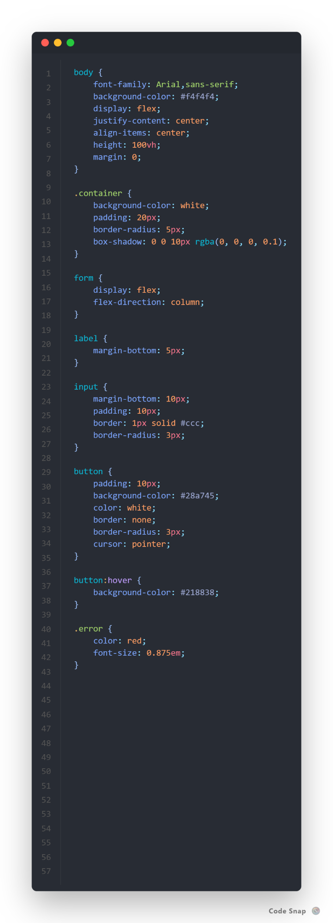

Step 3:
Adding JavaScript for Validation Finally, add JavaScript to validate the input fields using Validator.js and display error messages
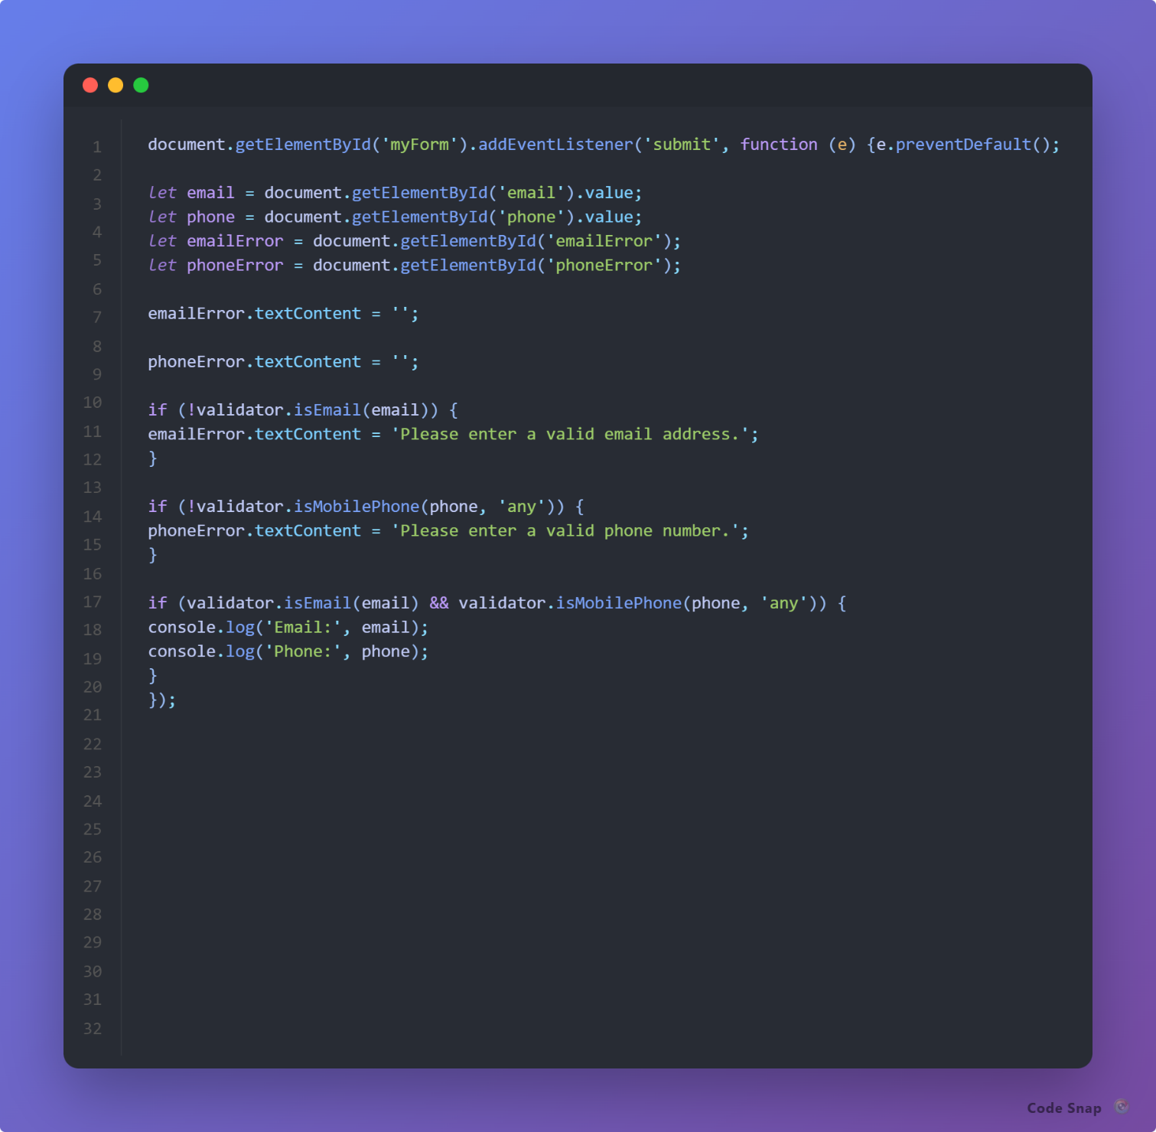
OUTPUT

Error message for invalid email:
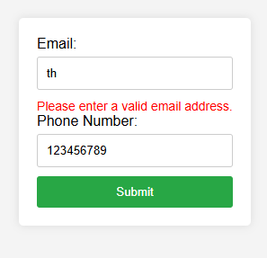

Error message for invalid phone no. :
